1. 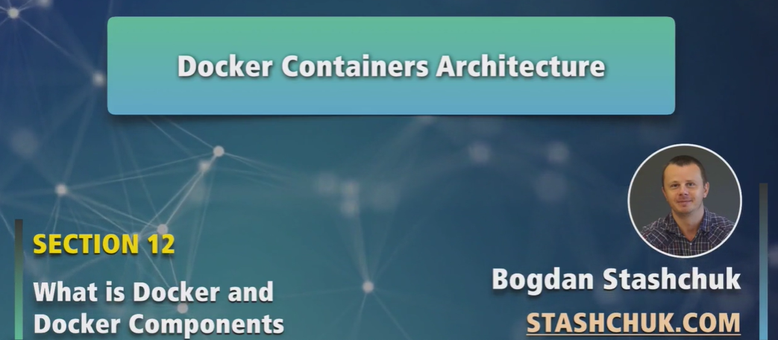
2. 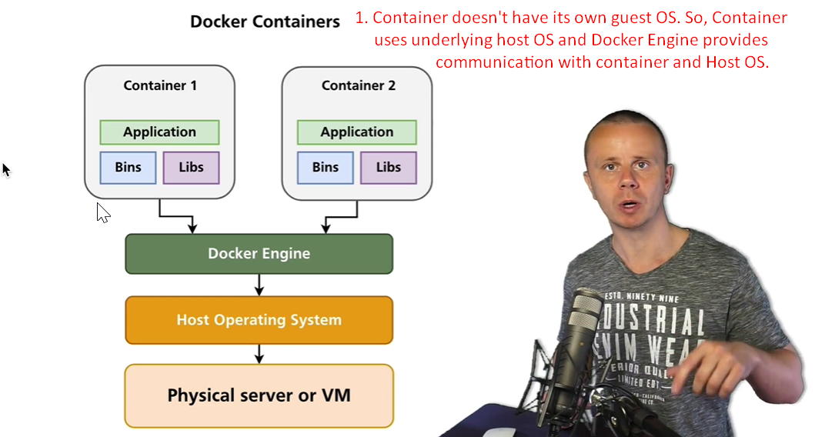
3. 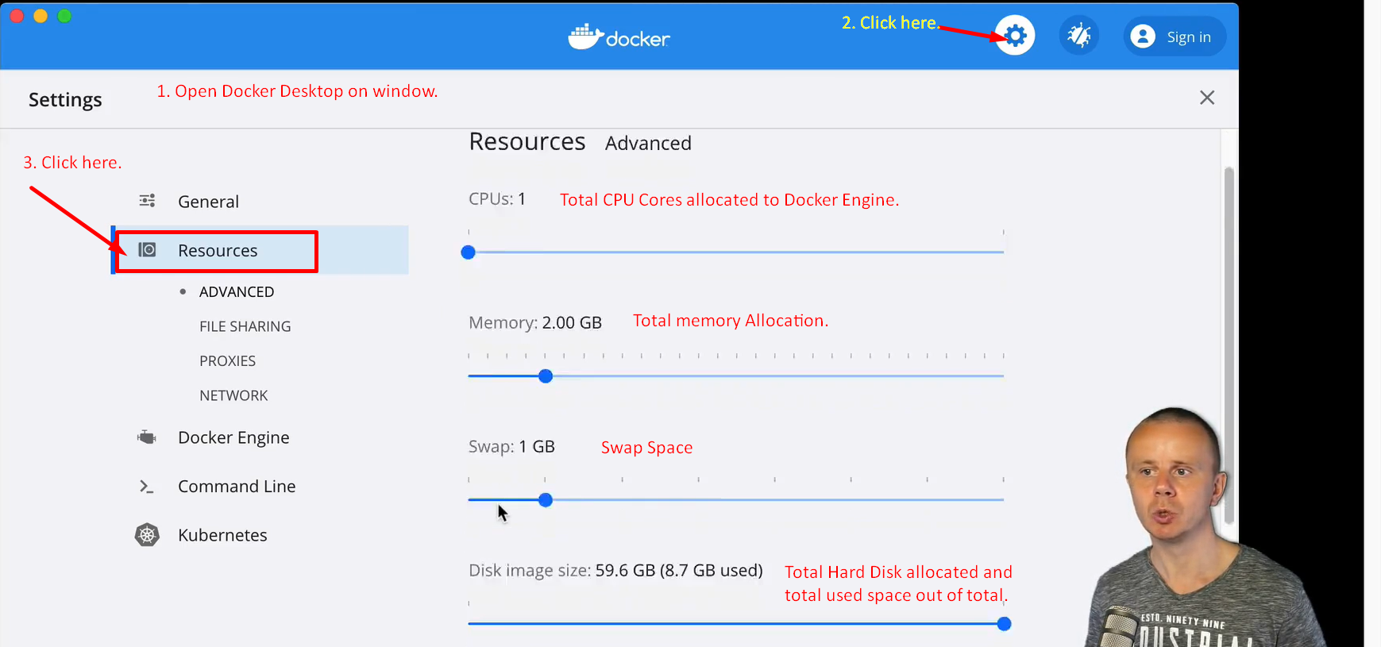
4. 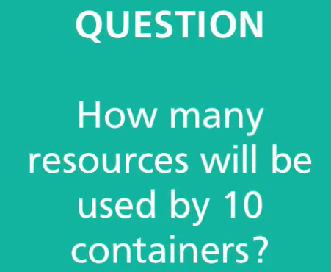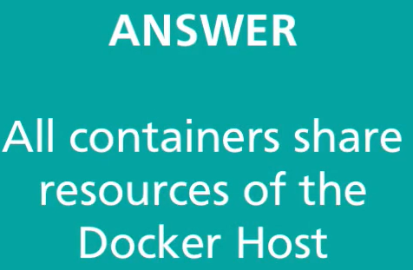
5. The difference b/w VM and Container:
   1. Containers share resources.
   2. Guest OS can’t be run inside container.
6. Then how it’s possible to run container on MAC OS, Linux or windows?
7. Let’s answer in next lecture.